CS 210 – Project Three - Corner Grocer Tracking Program Design and Functionality
Nenita Rice (June 19, 2026)
The Corner Grocer Tracking Program uses a modular design with separate functions for reading files, displaying the menu, searching for items, showing frequencies, and creating a histogram. A C++ map stores each grocery item with the number of times it appears, making the code organized, readable, and easy to maintain.
The program reads grocery items from an input file, counts their frequency, and automatically creates a backup file named frequency.dat. Users can search for a specific item, display all item frequencies, view a histogram using asterisks, or exit the program. It also checks file errors and invalid menu input.
Figure 1: Menu Option One
Prompts the user to enter an item and returns its frequency as a numeric value.
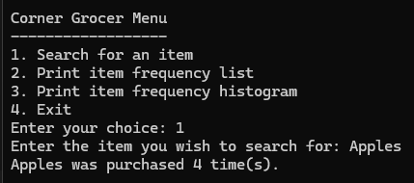
Figure 2: Menu Option Two
Displays every item from the input file along with the number of times it was purchased as a numeric value.
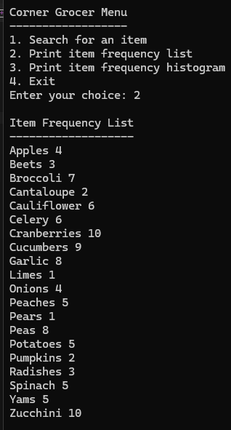

Figure 3: Menu Option Three
Displays every item from the input file followed by asterisks that represent how often the item was purchased.
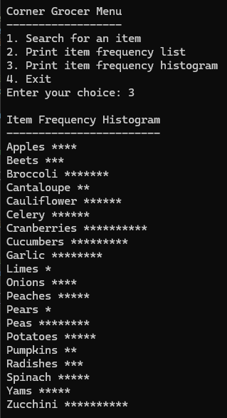
Figure 4: Menu Option Four
Exit the program
